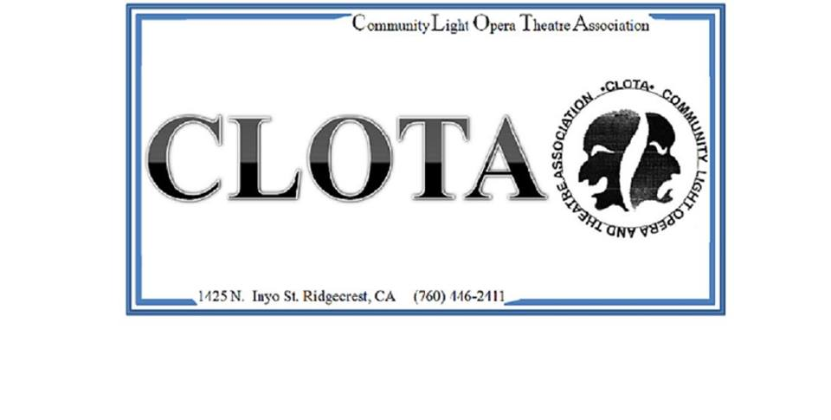

CLOTA Membership Form
Website: clota.org
Email: rc.clota@gmail.com
Address: PO Box 957, Ridgecrest, CA 93555

New ____ Renewal ____ Total amount paid ________ Single $15.00 / Family $25.00

Name____________________________________ Phone_____________

Name____________________________________ Phone _____________

Address _____________________________________________________

____________________________________________________________

Email Address ________________________________________________

Newsletter Preference ___ Email ___ Regular Mail ___ Both

Membership is January 1 to December 31

May we print your phone number in the Membership Directory? Yes___ No___

CLOTA Wall of Stars

Silver Star $50 - $249
Bronze Star $250 - $499
Gold Star $500 and above

*All non-corporate contributions include membership
*Contributions above the basic membership levels are tax deductible.

